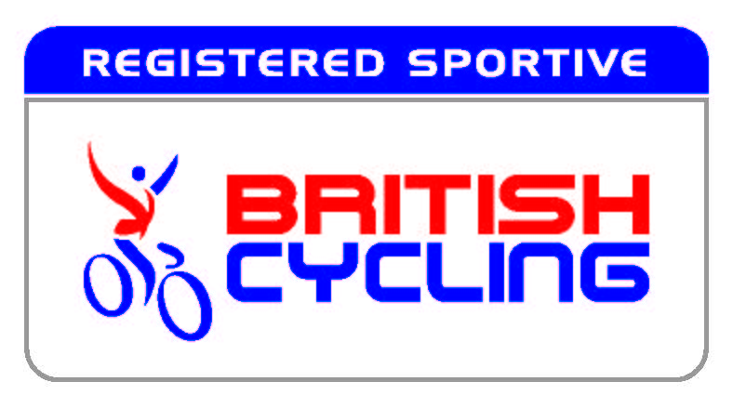
BRITISH CYCLING NON-COMPETITIVE EVENT ENTRY FORM
(under British Cycling Guidelines)

Please complete the below and post with your payment to: Sams Ride c/o The Old Rectory, Fyfield, Andover, Hants, SP11 8EL. Payment should be made to SNODROX LIMITED

All information is for the event organisers reference.

Event name: | SAMS RIDE 2018 | Event date: | 27/05/2018
Title: |  | Date of Birth:
First Name: |  | Surname:
Address:
Contact number:
Email:
Emergency contact name;
Emergency contact number:
Medical Conditions (if applicable):
Ride Distance (miles):  – tick one | ⃝ 25 (£25.00) | ⃝ 50 (£30.00) | ⃝ 100 (£30.00)
Riders under 25 on the day of the event pay only £25.00
I enclose an entry fee (Payable to Snodrox Limited) of: | £

"I agree to abide by the British Cycling Regulations for non-competitive cycling events, and understand and agree that I participate in this event entirely at my own risk, that I must rely on my own ability in dealing with all hazards, and that I must ride in a manner which is safe to myself and others. I am aware that when riding on a public highway the function of marshals is only to indicate direction and that I must decide whether the movement is safe. I agree that no liability whatsoever shall attach to the promoter, promoting club/Organisation, event sponsor, British Cycling or any event official or member of British Cycling or member of the promoting club/organisation in respect of any injury, loss or damage suffered by me in orby reason of the event however caused. I will participate in cycling events in a loyal and sporting manner. I will submit to disciplinary measures taken against me and will take any appeals and litigation to the authorities provided for in the Regulations. Subject to that reservation, I shall submit to any dispute that may arise exclusively to the courts. I have read and agree to abide by the above declarations”.

Signed:
Date:

ENTRIES WITHOUT CORRECT FEE OR DETAILS WILL NOT BE ACCEPTED. ACCEPTANCE OF YOUR ENTRY WILL BE NOTIFIED BY EMAIL

